Ethos-lua Tutorial

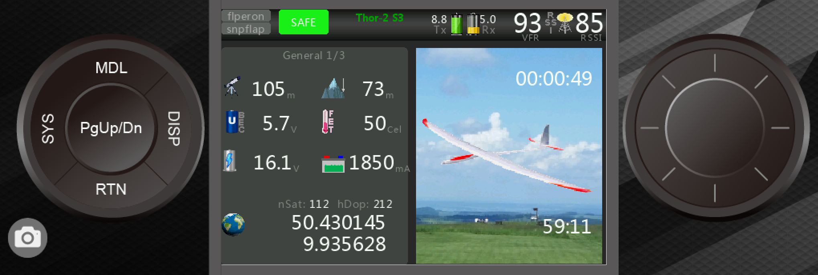

Inhaltsverzeichnis
General Information 4
Objective of the Tutorial 4
Structure of this Documentation 4
Typical use cases 5
Lua Files: Naming Convention and Directory Structure 6
Where do these scripts belong, where can I find them, and how do I manage them ? 6
The different types of Lua scripts in Ethos 7
Widget 7
System Tool 7
Source Scripts 7
Task Scripts 7
Other Scripts 7
the process of register scripts 8
What does "registration" mean? 8
handler 9
init 9
create 9
wakeup 9
paint 9
event 9
configure 9
read 9
write 9
menu 9
close 9
Startprozesse 10
Die Arbeitsumgebung 11
Editoren 11
Nutzung des Simulators zur Entwicklung 11
Weitere Informationsquellen 12
Ein ganz einfaches widget Beispiel: 12
Kapitel 2: das erste kleine sinvolle widget 13
das widget, die Aufgabe: 13
die grundlegenden Bausteine dazu 13
Variablen: Deklaration, Nutzung, Seiteneffekte 13
Wie erhalte ich Werte aus Quellen wie Telemetrie, Schalter, Geber, etc.. 13
Werte auf darstellen, der einfache Weg 13
etwas Wissen über audio und sounds 13
lcd.invalidate(): was macht das, warum, und wie gehe ich damit um ? 13
Das Ergebnis, der Code: 14
Kapitel 3: die widget Konfiguration 15
(2) Screenlayout auswählen 16
(3) widget allgemein einrichten 16
(4) Konfiguration der einzelnen Apps 17
Telemetrie 17
Picture 18
Kurveneditor 19
TopFull 20
Anhang 21
Modellspezifische Konfiguration 21
Standardsettings der Apps 22
Landesspezifische Texte / Sprachdateien 23
Beispieltemplate „Alpina“ 24
Internals 25

Chapter 1: A Brief Introduction

General Information

Objective of the Tutorial

(Small note: If you don't want to read introductory chit-chat, please skip directly to “Ethos-Lua Basics”)
This tutorial imparts the basic knowledge of Lua programming under Ethos. Upon completion of the tutorial, the user should be able to independently program smaller Lua applications. A prerequisite is familiarity with PC technology and basic programming knowledge. It is not strictly necessary to have previously programmed in Lua. Even “Basic” as a programming language would already have provided the necessary background knowledge. This is the first version of the tutorial, and it will be progressively refined and expanded later. If the meaning of terms (e.g., handler, interpreter, etc.) is unclear, I kindly ask that you first clarify the term using a search engine.
A glossary will be developed later.
The aim is not to teach programming fundamentals completely from scratch. However, links will branch off to Lua beginner courses and reference pages.

Structure of this Documentation

The guide follows a “Top-Down” approach.
From the general to the specific.
The section up to and including “Ethos Lua Basics” can also be interesting for pure Lua users to improve their understanding of handling Lua scripts.
First, general contexts, terminologies, functionalities, and the working environment are explained.
After that, you start with example tasks, how to implement them, and the respective demo-Luas.
Individual chapters bundle the topics.
It aims to impart more detailed understanding from simple requirements to more complex tasks.
In the end, each participant should be able to continue self-educating according to their individual needs.
Einzelne Kapitel bündeln die Themengebiete
Es soll von einfachen Anforderungen hin zu komplexeren Aufgaben immer mehr Detail-Verständnis übermittelt werden
Am Ende sollte jeder Teilnehmer in der Lage sein, sich autodidaktisch weiter auf seine individuellen Bedürfnisse hin Fortzubilden

Typical use cases
![Ethos-lua-tutorial ](https://github.com/strgaltdel/Ethos-lua-tutorial/blob/main/doc/bmp/00%20main/sample.png)
Why should you even bother with Lua for an Ethos transmitter?
When you look at the Ethos GitHub pages and the issues, there are many individual use cases and extension requests from users who demand very specific functionalities or display variants.
Very often, such a requirement fits a very limited user base and could even have negative side effects for other users. Even if the desired function/extension were implemented optionally, additional fields for possible parameterization or activation would have to be maintained in various Ethos menus.
Furthermore, every additional implementation consumes memory, costs CPU resources, increases maintenance effort, and ties up developer resources. So if an extension/idea only serves a small user base but imposes restrictions on the general user base, one should consider whether alternative implementations might be a better solution.
This is where Lua steps in and allows the user to implement their individual needs on their transmitter themselves if the idea is really important to them. Additionally, they can share their "project" with the community (e.g., via GitHub).
Is that too abstract? Examples might include:
- Displaying more than one telemetry value in larger fonts with freely selectable color options
- Announcements whose logic goes beyond what is possible with LSWs
- Individual design of the transmitter's homepage, etc.
Otherwise, Lua scripts are also often used by accessory providers to configure their hardware or, as in functional model building, to extend functionalities via the touchscreen.

Lua Files: Naming Convention and Directory Structure

I would like to start with the absolute basics that do not contribute at all to the knowledge of programming:

Where do these scripts belong, where can I find them, and how do I manage them ?
Basic Guidelines for Lua Scripts
All scripts must be located in a subdirectory named "scripts".
This directory is typically found on the data volume/drive named "NAND" for transmitters with larger NAND storage. For transmitters with smaller NAND storage, such as X20/X20s, it is located on the SD card. (For the former, the user can choose to store the scripts on the SD card if preferred).
Lua scripts can be identified by the suffix ".lua" (uncompiled) or ".luac" (compiled).
A simple script that consists of a single file can be placed directly in the /scripts directory with a freely chosen filename.
Alternatively, a subdirectory can be created. In this case, the file must be named "main.lua" or "main.luac".
In general, I recommend using the subdirectory option for better organization. The folder should be given a clearly identifiable name.
As always, adhere to the naming conventions for Ethos (considering maximum filename length, special characters, etc.).

The different types of Lua scripts in Ethos
In Ethos, there are various types of Lua scripts, which are "optimized" for their specific tasks in terms of functionality.
The most common ones are:

Widget
The most well-known type is probably the widget. These Lua scripts are used on the home screens.
Home screens, which are the screens you see immediately after turning on the transmitter or can scroll through afterward, have user-defined different layouts and frame sizes for a widget (up to full screen). One Lua script can be configured per frame. The Lua script essentially "lives" in this frame and sees it as its "validity horizon."
This means, for example, that when drawing, you cannot draw outside this frame, and the top left corner always has the coordinates 0,0, no matter where the frame is located on the screen.

System Tool
The system tool script is a "one-time script" that is manually started via the system menu, and no further actions are executed after exiting. A typical application is configuring devices such as (gyro) receivers, ESCs, redundancy boxes, etc.

Source Scripts
Anyone who has worked with Ethos for a while knows the term "source" or "sources." In many menus, "sources" from categories like analog inputs, switches, telemetry values, etc., can be selected to provide values. Once a source script is configured into a model, it can also provide (script-calculated) values.

Task Scripts
In these scripts, tasks can be processed in the background, for example, event-driven tasks that do not require displays on the screen or output of values in the form of the source category.

Other Scripts
Besides the scripts mentioned above, there are other types with very specific applications, for example, for RF modules like multiprotocol, Ghost, ELRS, Crossfire.

the process of register scripts

What does "registration" mean?
All scripts found on the transmitter must be "registered" when the transmitter starts, and thus be made known to the operating system. This happens regardless of which scripts are actually used in the respective model. After completing the boot process, the transmitter essentially has a "catalog" of available scripts of the respective types and can then present selection lists during operation.
Each Lua script is divided into certain "modules," called handlers, each covering specific tasks (e.g., data processing in the background, controlling/drawing the display, configuring widgets, reading or saving configurations, catching and evaluating events).
Each script must define the so-called init handler so that the respective script is registered when the transmitter starts. During this process, it is also indicated which "modules," or additional handlers, are used in the script.
The method to register such a script is a "system function" and thus from the system class.
A widget, for example, is declared with the method system.registerWidget(). Here is a possible example of a complete init handler for a widget as a code snippet:

local function init()
system.registerWidget({key="Xample", name="Example", create=create, wakeup=wakeup, paint=paint})
end

- key is the UNIQUE key for the script; it must not be repeated in any other script, regardless of the type.
- name is the name presented in a selection list.
- create is the handler that is executed the first time the script is called and is assigned to the function of the same name create.
- Accordingly, the background handler wakeup is defined.
- And also the paint handler for graphical representations.
A detailed overview of the script-type-specific registration methods and parameters can be found in the online documentation or the Lua Reference Guide, the source of which will be listed later.

handler

init

create

wakeup

paint

event

configure

read

write

menu

close

Startprozesse

Die Arbeitsumgebung

Editoren

Nutzung des Simulators zur Entwicklung

Weitere Informationsquellen

Ein ganz einfaches widget Beispiel:

Kapitel 2: das erste kleine sinvolle widget

das widget, die Aufgabe:

die grundlegenden Bausteine dazu

Variablen: Deklaration, Nutzung, Seiteneffekte

Wie erhalte ich Werte aus Quellen wie Telemetrie, Schalter, Geber, etc..

Werte auf darstellen, der einfache Weg

etwas Wissen über audio und sounds

lcd.invalidate(): was macht das, warum, und wie gehe ich damit um ?

Das Ergebnis, der Code:

Kapitel 3: die widget Konfiguration

(2) Screenlayout auswählen

(3) widget allgemein einrichten

(4) Konfiguration der einzelnen Apps

Telemetrie

Picture

Kurveneditor

TopFull

Anhang

Modellspezifische Konfiguration

Standardsettings der Apps

Landesspezifische Texte / Sprachdateien

Beispieltemplate „Alpina“

Internals

Rev 0.1
unow, Juni 24

